**Game mechanic proposal – template**

**Student name and surname**: Liam West

**Student number**: 10522700

**Name of the game**: Spitfire Assault

**Target platform**: PC (windows)/Xbox (uses Xbox controller, however this can be plugged into any PC)

**Controls**:

Reference: <https://pauked.com/blog/files/Xbox360Controller.png>

Left Analog Stick (X axis) = yaw, slight roll

Left Analog Stick (Y axis) = pitch

Right Analog Stick (X axis) = roll

Left bumper (hold) = decelerate

Right bumper (hold) = accelerate

Y button = changes camera view

Right trigger = Shoots bullets

Left trigger = Drops bombs (Only in different camera view)

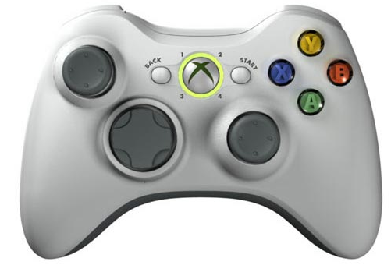

**Tools**:

(please provide a list with all the tools you are using – project management, coding, repo, etc)

**Project Management**

Trello & Elegantt: <https://trello.com/invite/b/SQO37iFY/b3f0b91a1395aed5ca17b80b140e3dec/progress-board-gamemechanic>

**Research**

StoryBoards (created on):

<http://storiesonboard.com/>

Mindmaps (created on):

<https://coggle.it/>

Moodboards:

Powerpoint

**Coding**

Unity (C#)

**Design**

3DS Max (Will be used in the future for models)

Audacity (Will be used for sound design)

**Repo**

GitHub:

<https://github.com/lwest2/AINT254GameMechanic/invitations>

**Additional**

Piazza – AINT254 class

**Story**:

(story of your game)

You are a pilot of the iconic 'Supermarine Spitfire' aircraft during WW2, flying across vast enemy territory. Use split second decision making to evade the path of the bullets. Try destroy all main objectives with the immense fire power of the aircraft.

**References/Inspiration**:

(games or parts of a game that inspired you – add screenshots, descriptions, etc…try to capture the essence of that particular game and why is relevant to your game)

**WarThunder**

<https://www.youtube.com/watch?v=as01et3f7YY>

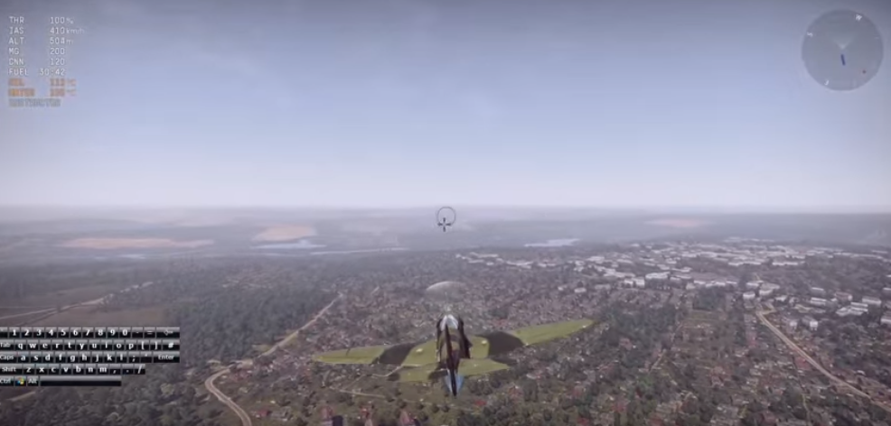

Shows flight mechanics of the game quite well. The manoeuvres that the aircraft displays are smooth and have a sense of realism. There’s lots to explore with this flying mechanic and strategies. This is something I want to replicate in my game mechanic.

**Battlefield 1**

<https://www.youtube.com/watch?v=EECmxMLXI3U>

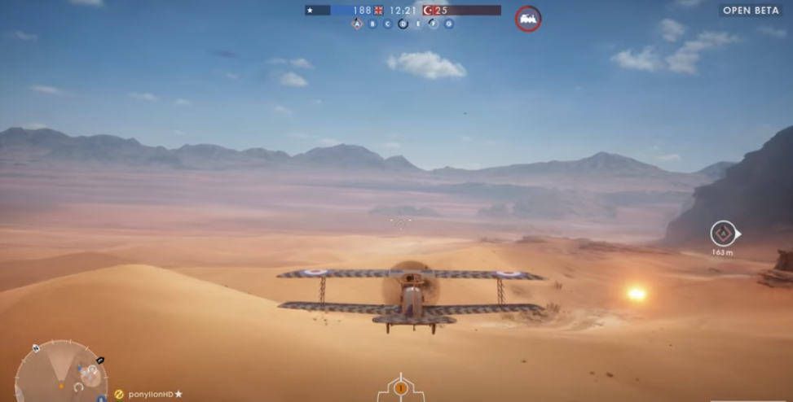

Even though this is a triple AAA game with a high budget, the mechanics are still inspirational and I can try to implements something similar into my game. The way the aircraft shoots at players is something I would like to implement. Instead of players it will be the objective (turrets).

**Aim**:

(describe what you are trying to achieve – please add everything that is relevant - mind maps, sketches, drawings flow diagrams, description of methods, screenshots)

**Overview**

The player controls an aircraft which must destroy the turrets located around the map. The player can be shot down by the turrets and lose the game if they are not careful. Once the player destroys all turrets, they win the game.

**Initial Idea**

**Breakdown of Specification**

"Mechanics Prototype; A unique/custom game mechanic prototype for a single player or two players on the single screen, iterated to a high standard."

* Must be unique or custom
  + What features could be added to make a game mechanic unique?
* Single player
  + Controls: Xbox controller
* Two players
  + Controls: Keyboard and mouse, Xbox Controllers
  + Split screen
  + 1 screen, which covers the whole map
* Iterations must be included. Sprints/scrums.
* Refined touches for the end mechanic.

**Toy Analysis – Coggle Mindmap**

<https://coggle.it/diagram/WeeZLniayQABWhmi/df78e2d706612ba183baa7a874334a176bdee1189ed7e6f661a24f5d380750f0>

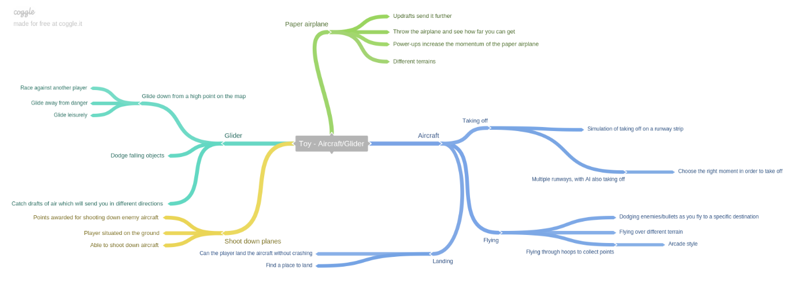

**Toy**

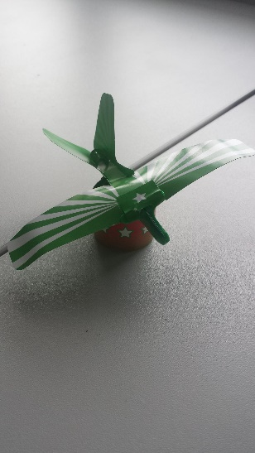

**Chosen Idea**

**Main mechanic**   
Imagine a flight simulator, but for World War 2!

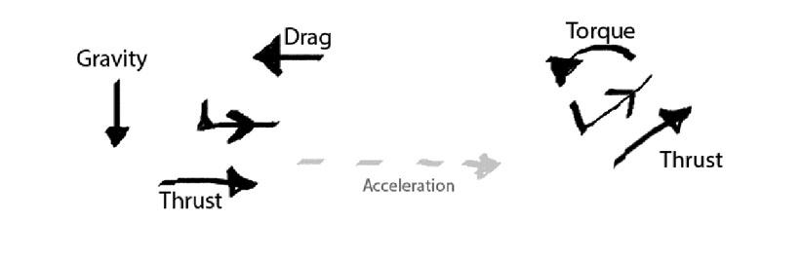

Originally the player could take off from a runway. This was later iterated on and then changed so you immediately start in the air.  
  
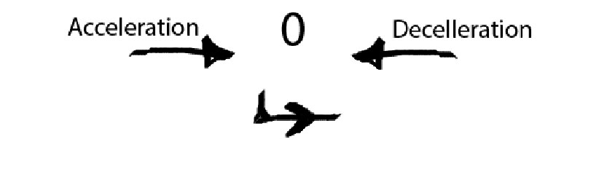

Left bumper decelerates. Right bumper accelerates. Holding both of these will keep constant velocity.  
  
  


Left Analog Stick (Y axis) changes the pitch of the aircraft so it can fly upwards or downwards. It will try to stabilize the pitch if there is no roll.

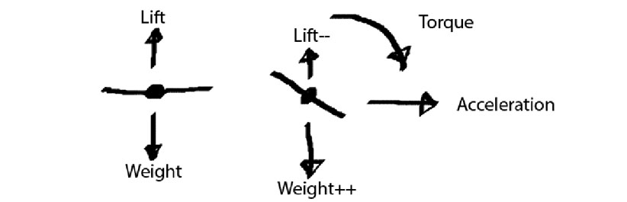

Yaw can be adjusted with the Left Analog Stick (X axis), which will in-turn, add slight roll. Additional roll can be added with the Right Analog Stick (X axis). This will stabilize if roll has no input. This gives the player easy control over the aircraft.

**Breakdown of Mechanics**

Mindmap

Original iteration

<https://coggle.it/diagram/Weef4BLp_AABU-SV/208c0e8bbbf98bf3789ce8dda2d0234c41f0e57c4702d8976464f8bc8c341a3c>

Adjusted iteration

<https://coggle.it/diagram/WfifUKt7gQABo7ce/cb9d901d88669303eb8baf1b7327bd09d785b8f439776622095ac7747d5a5e01>

User storymap

Original iteration

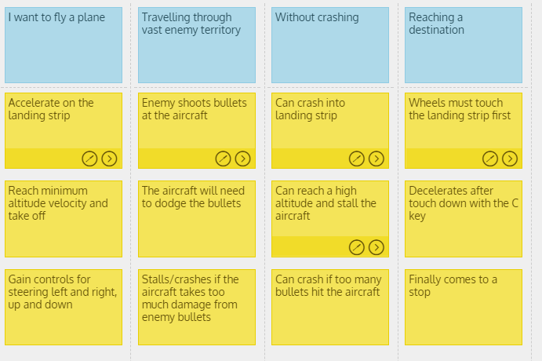

Adjusted iteration

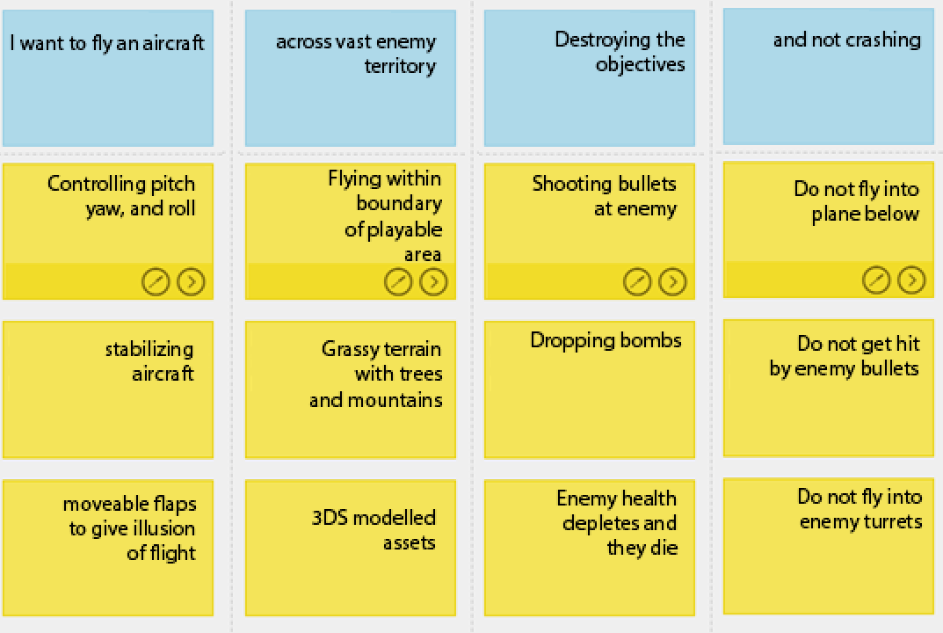

**Additional research**

**Aircraft Physics**

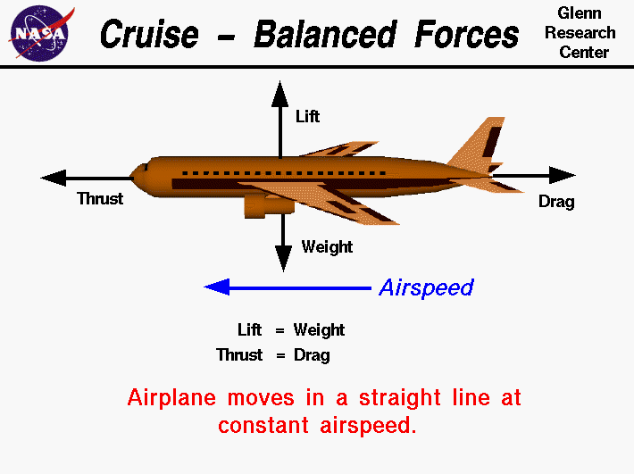

<http://ffden-2.phys.uaf.edu/211_fall2013.web.dir/Cody_Gaines/Aerodynamic%20Forces.gif>

These are some of the forces that will need to be taken into consideration.

The reason the aircraft creates lift is due to the air splitting at the front of the wings. The air pressure increases underneath due to the curvature of the wings. On top of the wings, the air accelerates downwards, creating lift.

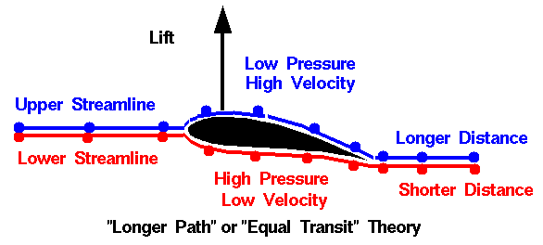

<https://upload.wikimedia.org/wikipedia/commons/2/2d/Equal_transit-time_NASA_wrong1.gif>

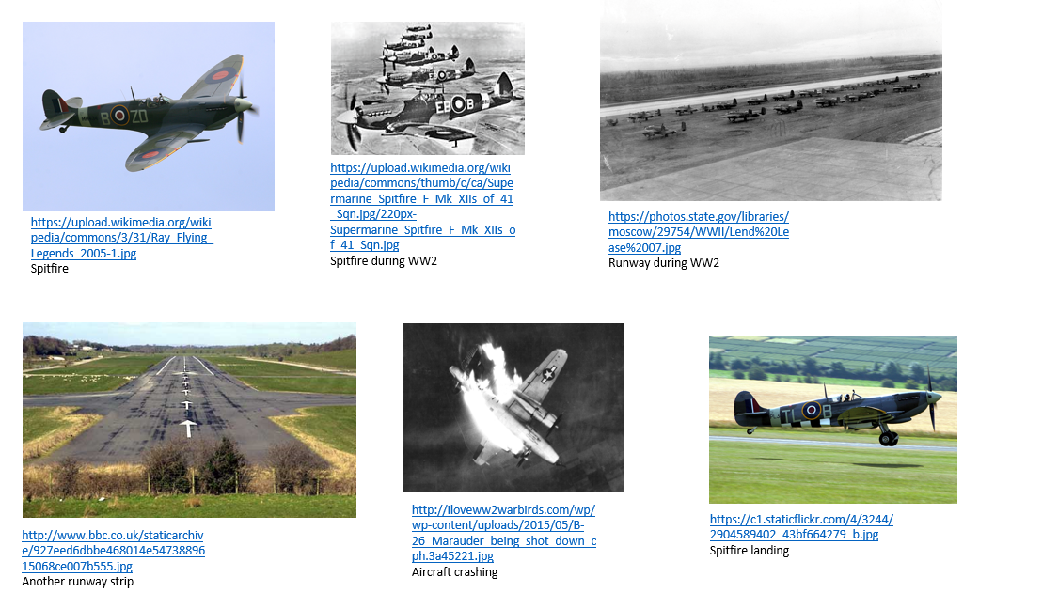

**Screenshots from first iteration**

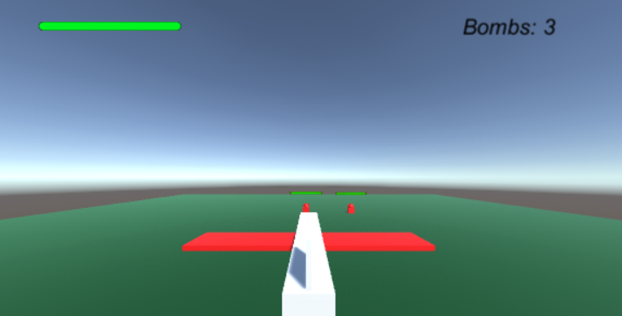

This screenshot shows the aircraft, GUI with health and the number of bombs the player has left to use, and 2 enemy turrets with health bars. The camera will follow closely behind the aircraft in a 3rd person view.

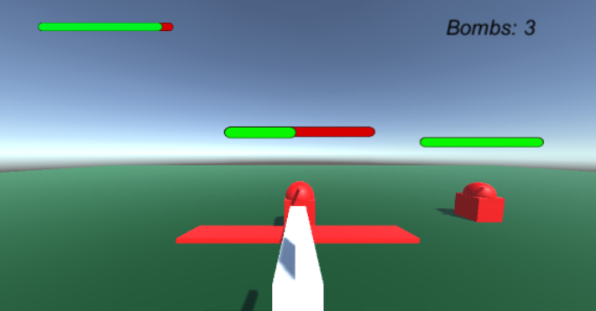

This screenshot shows the health bar decreasing as shots are fired.

**Methods**

I will be using the FixedUpdate method a lot of the time due to the use of the Unity Physics Engine. The update method will take in input.

**Classes**

Aircraft –

Changes pitch, roll and yaw with input. Accelerates and decelerates. Also stabilizes aircraft if there is no roll input.

AircraftCollision –

Takes care of what the aircraft colliders into, and what effect that has.

EnemyGun –

Invokes a method to fire a bullet at the player aircraft.

SwitchCamera –

If the player presses the Y button, a camera animation will start and hang the camera below the aircraft. A static bool is used here so that when the player wants to drop a bomb, he has to be in this camera position to do so.

TurretTakeDamage –

Deducts health from the slider, destroys game object when the health reaches 0.

FireProjectile –

Enemy projectile, if it collides with player then deduct health from player. Adds a velocity to the projectile.

playerProjectile –

Bullets and their collisions.

CameraFacingBillboards –

Makes worldspace canvas face player, so the health bars will always be visible.

Fire –

Input for attack triggers (bombs, bullets). Coroutine prevents increased rapid fire.

BombProjectile –

Takes care of collisions from the bomb.

**Assets**

Aircraft

Enemy turret

Player bombs

Player bullets

Enemy bullets

Plane (environment)

**Level Map**

Blue – Playable area

Orange/red – Enemy turrets

Green – Spawn location, player aircraft